Setting up allegro lib for project

First go to “Build options” of the project.
Add to project (here named “test_1”):
C:\allegro-5.0.10-mingw-4.7.0\include

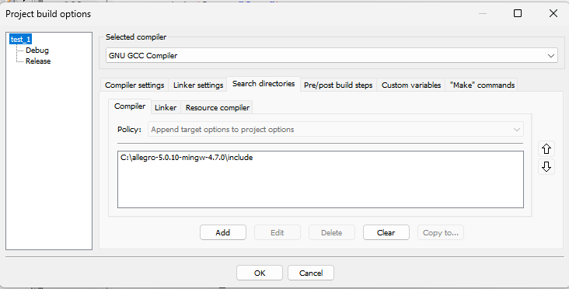
Add to Debug:

C:\allegro-5.0.10-mingw-4.7.0\lib\liballegro-5.0.10-monolith-mt-debug.a
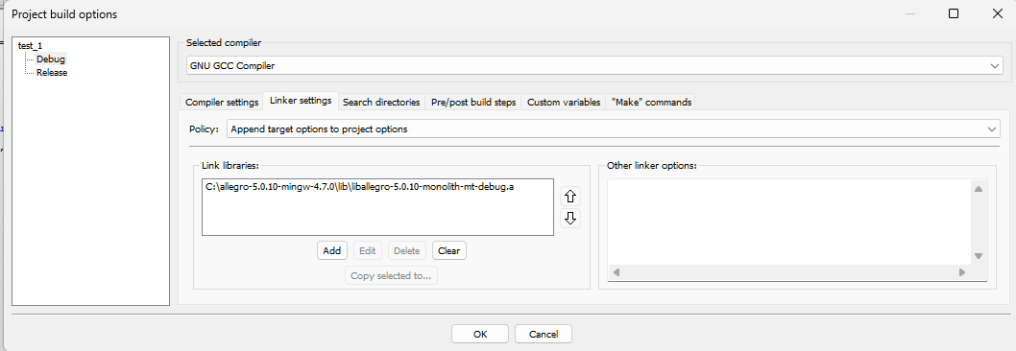
Add to Release:
C:\allegro-5.0.10-mingw-4.7.0\lib\liballegro-5.0.10-monolith-mt.a

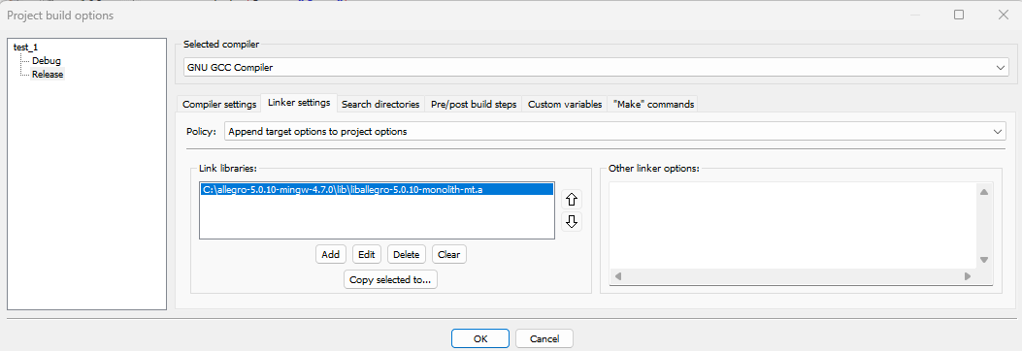
ff

As last add allegro-5.0.10-monolith-md-debug.dll, which can be found

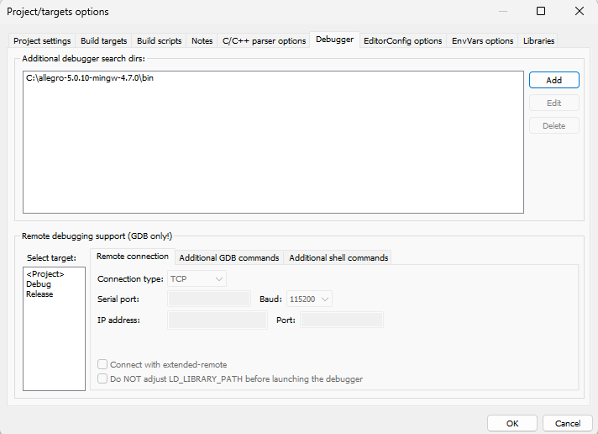
If you launch the code this error shows up.

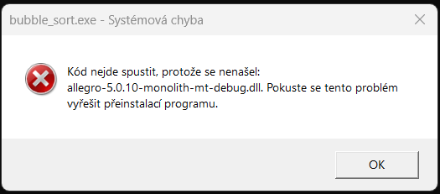

There two solutions.
A)
It can be solved by addin environmental variable to codeblocks

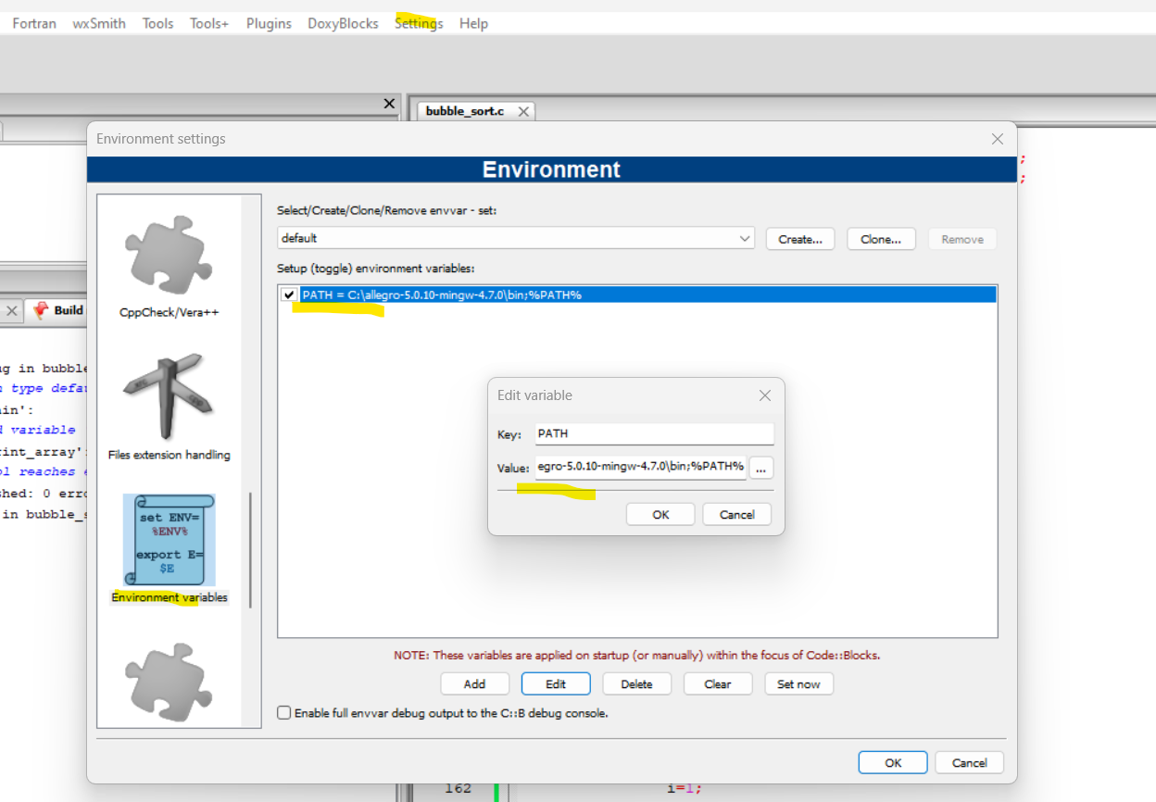
The problem if you launch the .exe file of the project from Debug folder. It will still throw the error and to issuficiently fix it you have to do B).

B)
Place allegro-5.0.10-monolith-mt-debug.dll which can be found allegro-5.0.10-mingw-4.7.0\bin in file in Debug folder together with the .exe file.

